Transport order for Excel4JPK 1.(008)
Table of contents

1. Description 2
2. Transport order 2
2.1. Update from Excel4JPK >= 1.0(006) 2
2.2. Update from Excel4JPK < 1.0(006) 3
2.3. New installation of Excel4JPK 3
3. List of changes 3

Description

Minimum JPK version required is JPK 3.3(002).
Minimum Excel4JPK update version is Excel4JPK 1.0(006) otherwise import start package of workbench transports.

You can check SAF-T version in TCODE /BCC/JPK button „About application”
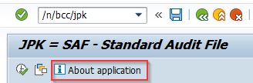

You can check Excel4JPK version in TCODE /BCC/JPF button „About application”
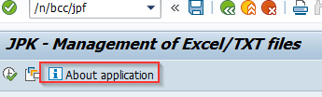

S4 and ECC has same update transports.

Transport order

Important: For JPK version <=3.3(002) it is necessary to add transport BE6K948508 fist. It includes changes in JPK objects. This change will be included in JPK 3.3(003) update. Importing this transport for JPK version after 3.3(003) is not recommended as it may overwrite objects from JPK solution.

Update from Excel4JPK >= 1.0(006)
Update if Excel4JPK version >= 1.0(006).

Number | Type | Description | Comment
BE6K948508 | Workbench | Adjustment of JPK objects | Import only if JPK version <= 3.3(002). Otherwise skip this transport.
BE6K948510 | Workbench | Update to Excel4JPK 1.0(008)
BE6K948516 | Customizing | Update to Excel4JPK 1.0(008)

Update from Excel4JPK < 1.0(006)
Update if Excel4JPK version < 1.0(006).

Number | Type | Description | Comment
BE6K948508 | Workbench | Adjustment of JPK objects | Import only if JPK version <= 3.3(002). Otherwise skip this transport.
BE6K948512 | Workbench | Excel4JPK 1.0(008) Start pack
BE6K948516 | Customizing | Update to Excel4JPK 1.0(008)

New installation of Excel4JPK
Number | Type | Description | Comment
BE6K948508 | Workbench | Adjustment of JPK objects | Import only if JPK version <= 3.3(002). Otherwise skip this transport.
BE6K948512 | Workbench | Excel4JPK 1.0(008) Start pack
BE6K948518 | Customizing | Excel4JPK 1.0(008) Start pack

List of changes

- Added support for JPK VDK – V7M structure
- Added support for JPK FA(3) structure
- Fixed bug where some file entries were invisible after file validation
- New validation for JPK FA header. Additional check for field RODZ_FA. Field should contain only SP(sale) or ZK(purchase) values.
- New validations for JPK VAT. Fields DATAZK and DATAWYS will be validated only for dedicated sales/purchase rows. Removed DATASP form validation/field is optional.

IMPORTANT:
Manual step required to activate new validation in JPK VAT.
Check implementing class In /BCC/JPKC.

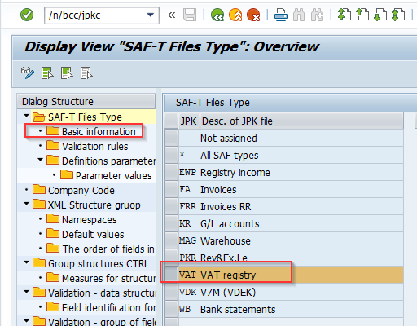

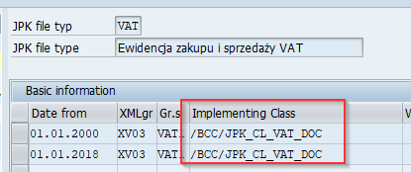

Manual step in transaction /BCC/JPFC
- For class /BCC/JPK_CL_VAT
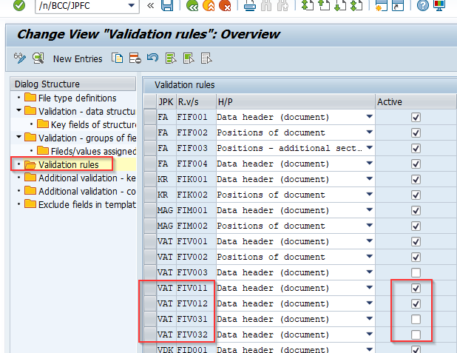
Activate rules FIV011 and FIV012. Make sure that FIV031 and FIV032 is inactive

- For class /BCC/JPK_CL_VAT_DOC

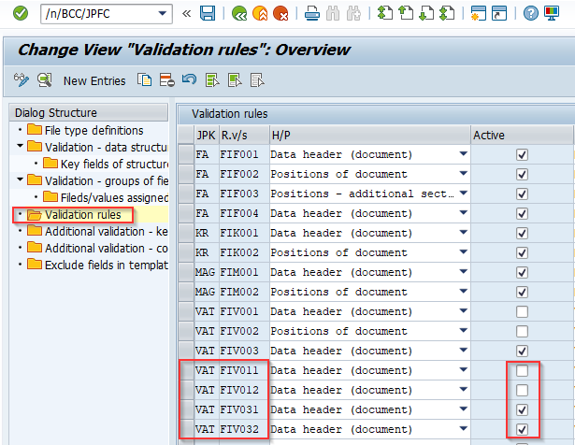
Activate rules FIV031 and FIV032. Make sure that FIV011 and FIV012 is inactive

- Added message in case of incorrect data format.
Previously in case of incorrect data from in one of the Excel columns program didn't show any message although file wasn't imported. Now, when this happens program will display short error message with information which value in which column is causing the error.

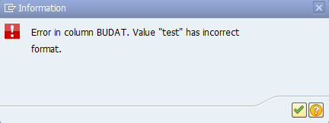

- New functionality which allows to import Excel file in smaller packages. It was impossible to load single file with more than 65 536 rows . By setting new parameters in /BCC/JPKC JPF001(activate) and JPF002(number of rows in single package) it is possible to pass this limitation. Program will read file in smaller packs and will merge them to result table.

/BCC/JPKC – parameters:

File type | Parameter | Values | Description
* | JPF001 | X/empty | Activating read file in packages
* | JPF002 | Number | Number of rows in single package

- Fixing the issue when user wanted to add file with header data only. In case of two layer structures where headers' and positions' data were imported in separate files it was impossible to change only header data. Program during data loading required both header and position files and if there was no file for positions we get ABAP error. Now it is possible to import files with header data only.

- Additional criteria for automatic file import. Functionality is described in separate manual
New parameters for this functionality
File type | Parameter | Values | Description
* | JPF003 | SAF-T file type | Activating additional criterium for structure.  Possible Entries  - KR  - WB  - MAG  - FA  - VAT  - VDK
KR | KRF001 | Table, name of fields on selection screen | Additional criterium definition for JPK KR
WB | WBF001 | Table, name of fields on selection screen | Additional criterium definition for JPK WB
MAG | MAGF01 | Table, name of fields on selection screen | Additional criterium definition for JPK MAG
FA | FAF001 | Table, name of fields on selection screen | Additional criterium definition for JPK FA
VAT | VATF01 | Table, name of fields on selection screen | Additional criterium definition for JPK VAT
VDK | VDKF01 | Table, name of fields on selection screen | Additional criterium definition for JPK VDK/V7M

